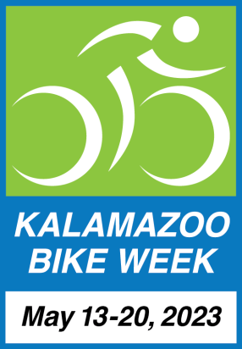
FOR END OF APRIL RELEASE

Contact:
Paul Selden, Chair
Kalamazoo Bike Week 2023
bikeweek@bikefriendlykalamazoo.org
(269) 598-8301 (cell)

Kalamazoo Area Bike Week Coming Saturday May 13-20, 2023
Dozens of Ways to Participate

Kalamazoo, MI -- April 20, 2023. The 12th annual Kalamazoo Area Bike Week starts Saturday, May 13 and wraps up on Saturday, May 20. Spring is here, and cyclists are out and about. With families and children joining in the fun, Bike Week offers many ways to stay active and healthy, whether running an errand or out on a local adventure.

Honorary KBW Co-Chairs Kalamazoo Mayor David Anderson and Portage Mayor Patricia Randall welcome the greater community to enjoy another fun-filled week of rides and activities and will even be leading a Mayor’s Ride on Saturday May 20. Bike Week’s events and activities will be listed on a calendar at www.kalamazoobikeweek.org to raise awareness of the many opportunities to bicycle during the week and throughout the year. Events are being added to the calendar almost daily through the first week of May.

An Announcements page lists places to pick up bike safety tips, maps and safe passing yard signs while supplies last. The Announcements page also suggests ways to donate bicycles or drop off bike tires and inner tubes for proper disposal at no charge.

Kalamazoo Area Bike Week is one of the most event filled and oldest week-long celebrations of bicycling in the United States. Details for more than 30 featured activities, plus an updated downloadable prize-worthy Bike Week poster can be seen on www.kalamazoobikeweek.org. Bike Week 2023 spotlights:
- Locally available bicycle clubs, riding groups and shops
- Group riding on the roads and trails
- Using bicycles for everyday transportation and running errands
- Lessons on how to get bikes ready to ride and how fix a flat
- Bike Camp and Bike Rodeos - teaching safe riding skills for adults and kids
- Local bicycling developments
- Mountain, dirt & gravel road riding
- Public safety messaging
- A bike show featuring a collection of exceptional bicycles
- Bike-related nonprofits.

Bike Week is presented by Bike Friendly Kalamazoo, a Michigan non-profit organization. Paul Selden, BFK’s president observes, “Bike Week would not be possible without the efforts of many wonderful independent organizers and sponsors. Bike Week offers drivers and cyclists a great opportunity to put the Golden Rule into action just by following the rules of the road. It highlights the great ways bicycling builds community during this week, and year-round.”
###
Bike Friendly Kalamazoo (BFK) is a Michigan non-profit corporation whose mission is to help make our entire community even more bicycle friendly. Its volunteers and stakeholders are drawn from throughout Kalamazoo County and four adjacent townships and three villages in Van Buren County. BFK’s programs help improve the quality of life through bicycling and are supported in part by grants from the Irving S. Gilmore Foundation, the Marvin and Rosalie Okun Foundation, the Arts Council of Greater Kalamazoo, the Michigan Council for Arts & Culture, the Jim Gilmore, Jr. Foundation and corporate donations from Stifel Financial, Stryker Corporation and Bell’s Brewing. For more information please see www.bikefriendlykalamazoo.org.
###
Kalamazoo Area Bike Week 2023
Events & Activities
For details go to www.kalamazoobikeweek.org

May is National Bike Month

WKZO Radio Ken Lanphear Morning Show Interviews - All Week

Friday, May 12, 2023
9:10am WKZO Radio Ken Lanphear Morning Show Interview

Saturday, May 13, 2023 Bike Week Officially Starts
9am-12pm Vicksburg Bike Rodeo
9am-12pm Vicksburg Bike Check Up
10am KBC’s LGBTWAI+ Allies Ride
10am-3pm Bronson Park Cycle Show

Sunday, May 14, 2023
All Day Mother’s Day: Ride a Bike With Mom!
Noon-5pm Bike History Museum Visit
Start Bike Bingo Game
Teach Your Kids to Ride

Monday, May 15, 2023
9:10am WKZO Radio Ken Lanphear Morning Show Interview
9am Monday Morning Cruisers
6pm-8pm Mountain Bike Monday Cookout
6:15pm KBC Monday Night Ride

Tuesday, May 16, 2023
9:10am WKZO Radio Ken Lanphear Morning Show Interview
6:15pm Tuesday Evening Women’s Ride
7pm-9pm We Drink From the Same Well Ride

Wednesday, May 17, 2023
9:10am WKZO Radio Ken Lanphear Morning Show Interview
4pm-5pm Local Bicycling Developments: 2023 & Beyond Community Event
5pm-7pm Bike Rodeo
6:15pm KBC Wednesday Night Ride
6:15pm Group Ride with Refreshments After

Thursday, May 18, 2023
8:40am WKZO Radio Ken Lanphear Morning Show Interview
6:30-8pm Intro to Gravel Riding
Volunteer At A Bike-Related Charity
4pm-7pm Youth Open Shop

Friday, May 19, 2023
9:10am WKZO Radio Ken Lanphear Morning Show Interview
National Bike to Work Day
9:30am KBC Friday Morning Women's Ride
4pm-7pm Youth Open Shop

Saturday, May 20, 2023
8am-1pm Kalamazoo Bicycle Club’s Bike Camp
9:30am-10am Mayor’s Ride
Learn How To Fix A Flat
Join a Bike Club

Kalamazoo (Area) Bike Week 2023 Poster

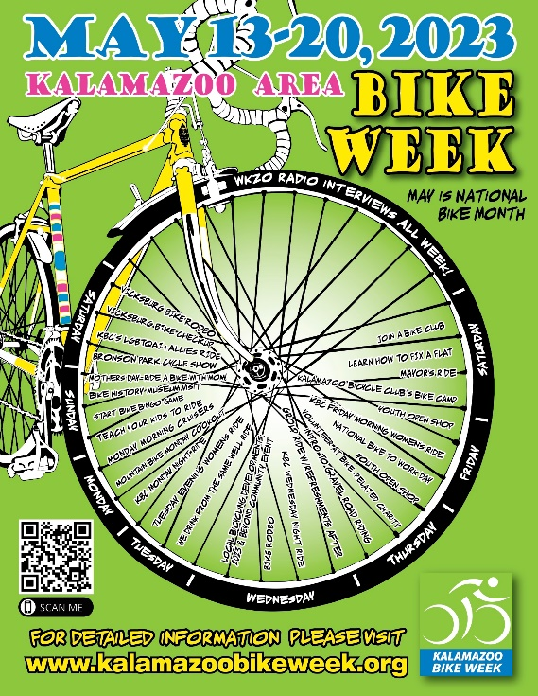
Original Design: Ludwig Betz
Graphic Updates: Wes Garman

