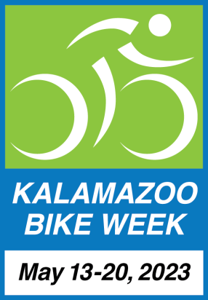
FOR IMMEDIATE RELEASE

Contact:
Paul Selden, Chair
Kalamazoo Bike Week 2023
bikeweek@bikefriendlykalamazoo.org
(269) 598-8301 (cell)

Kalamazoo Area Bike Week 2023 Starts Saturday
Dozens of Events Planned

Kalamazoo, MI -- May 11, 2023. The 12th annual Kalamazoo Area Bike Week starts Saturday, May 13 and wraps up on Saturday, May 20. Spring is here, and cyclists are out and about. With families and children joining in the fun, Bike Week offers many ways to stay active and healthy, whether running an errand or out on a local adventure.

Honorary KBW Co-Chairs Kalamazoo Mayor David Anderson and Portage Mayor Patricia Randall welcome the greater community to enjoy another fun-filled week of rides and activities and will lead Mayor’s Ride on Saturday May 20. Bike Week’s events and activities are listed on a calendar at www.kalamazoobikeweek.org to raise awareness of the many opportunities to bicycle during the week and throughout the year.

An Announcements page lists places to pick up bike safety tips, maps and safe passing yard signs while supplies last. The Announcements page also suggests ways to donate bicycles and drop off bike tires and inner tubes for proper disposal at no charge.

Kalamazoo Area Bike Week is one of the most event filled and oldest week-long celebrations of bicycling in the United States. Details for more than 30 activities, plus an updated downloadable artist-designed Bike Week poster are at www.kalamazoobikeweek.org.

Bike Week 2023 spotlights:
- Locally available bicycle clubs, riding groups and shops
- Group riding on roads and trails
- Using bicycles for everyday transportation and running errands
- Lessons on how to get bikes ready to ride and how fix a flat
- Bike Camp and Bike Rodeos - teaching safe riding skills for adults and kids
- Local bicycling developments
- Mountain, dirt & gravel rides
- Public safety messaging
- A bike show featuring exceptional bicycles
- Bike-related nonprofits.

Bike Week is presented by Bike Friendly Kalamazoo, a Michigan non-profit organization. Paul Selden, BFK’s president observes, “Bike Week would not be possible without the efforts of many wonderful independent organizers and sponsors. Bike Week offers drivers and cyclists a great opportunity to put the Golden Rule into action by following the rules of the road. It highlights the great ways bicycling builds community not only this week, but year-round.”
###
Bike Friendly Kalamazoo (BFK) is a Michigan non-profit organization working to improve the quality of life through bicycling. Its volunteers and stakeholders are drawn from throughout Kalamazoo County and portions of Van Buren County. BFK’s programs are supported in part by grants from the Irving S. Gilmore Foundation, the Marvin and Rosalie Okun Foundation, the Arts Council of Greater Kalamazoo, the Michigan Council for Arts & Culture, the Jim Gilmore, Jr. Foundation the League of Michigan Bicyclists, corporate contributions from Stifel Financial, Stryker Corporation, Bell’s Brewing and Clark Logic and individual donations from the Friends of BFK. For more information please see www.bikefriendlykalamazoo.org.
###
Kalamazoo Area Bike Week & Pre-Bike Week 2023
Events & Activities
For details go to www.kalamazoobikeweek.org

May is National Bike Month

On Air Interviews - All Week

Pre Bike Week

Friday, May 12, 2023
9:10am WKZO Ken Lanphear Morning Show Radio Interview

Saturday, May 13, 2023 Bike Week Officially Starts
9am-12pm Vicksburg Bike Rodeo
9am-12pm Vicksburg Bike Check Up
9:40am KBC’s LGBTWAI+ Allies Ride
10am-3pm Bronson Park Cycle Show

Sunday, May 14, 2023 Mother’s Day -- A great day to:
Ride A Bike With Mom!
Visit Historical Bikes at Local Museums (check museum hours)
Start Bike Bingo Game
Teach Your Kids to Ride

Monday, May 15, 2023
9:10am WKZO Ken Lanphear Morning Show Radio Interview
9am Monday Morning Cruisers
6pm-8pm Mountain Bike Monday - Cookout
6:15pm KBC Monday Night Ride

Tuesday, May 16, 2023
9:10am WKZO Ken Lanphear Morning Show Radio Interview
9:30am Volunteer at Bike-Related Charity
6:15pm Tuesday Evening Women’s Ride

Wednesday, May 17, 2023
9:10am WKZO Ken Lanphear Morning Show Radio Interview
4pm-5pm Local Bicycling Developments: 2023 & Beyond Community Event
5pm-7pm Bike Rodeo
6:15pm KBC Wednesday Night Ride
7pm We Drink from the Same Well Ride

Thursday, May 18, 2023
8:40am WKZO Ken Lanphear Morning Show Radio Interview
3pm-6pm Youth Open Shop
6:15pm Group Ride with Refreshments After
6:30-8pm Intro to Gravel Riding

Friday, May 19, 2023 National Bike to Work Day
9:10am WKZO Ken Lanphear Morning Show Radio Interview
9:30am KBC Friday Morning Women's Ride
3pm-6pm Youth Open Shop

Saturday, May 20, 2023
8am-1pm Kalamazoo Bicycle Club’s Bike Camp
9:00am-10am Mayor’s Ride
Learn How to Fix A Flat
Join a Bike Club

Kalamazoo (Area) Bike Week 2023 Poster

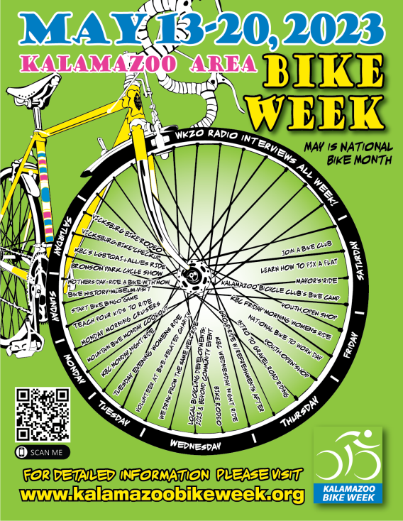
Original Graphic Design: Ludwig Betz
Graphic Updates: Wes Garman

